

SRI LANKA INSTITUTE OF INFORMATION TECHNOLOGY

[**Enterprise Standards and Best Practices for IT Infrastructure**](http://courseweb.sliit.lk/course/view.php?id=137)

**4th Year 2nd Semester 2016**

Name: Herath H.M.D.M

SLIIT ID: IT 13 1343 72

Practical Session: WD

Date of Submission: 2016/7/29

**Windows** **Instance**.

1. Login to AWS and select EC2 to launch the instance.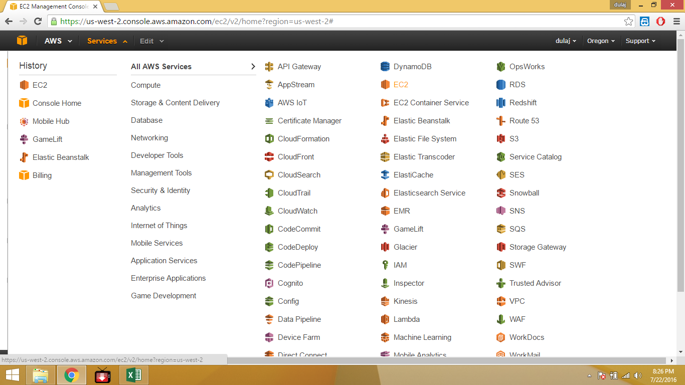
2. 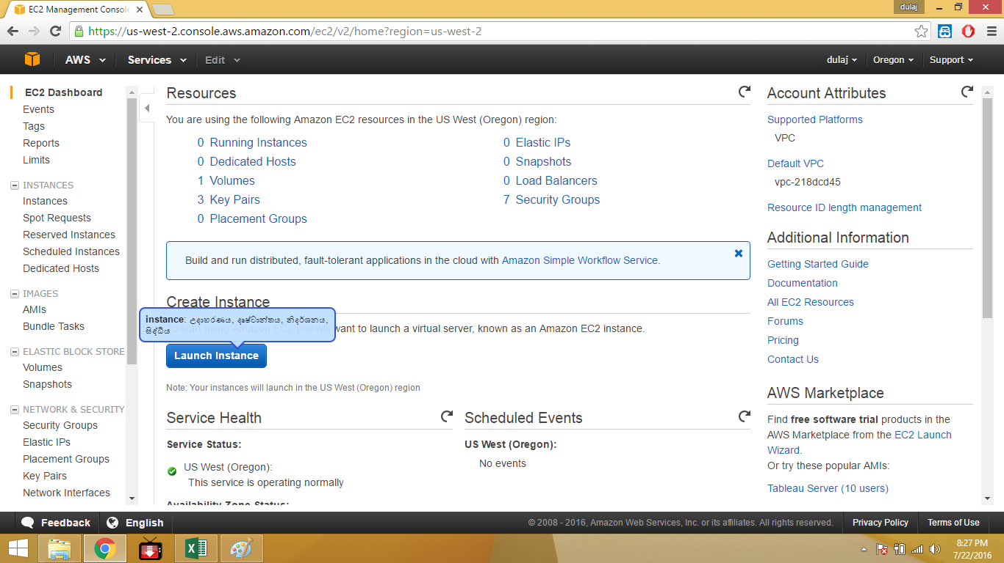Select “Launch Instance”.
3. 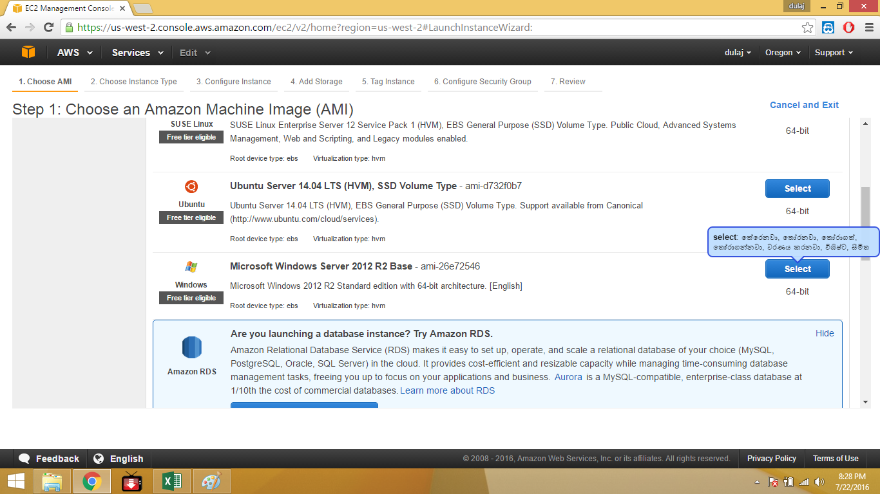Select Microsoft windows server 2012 R2 Base.
4. 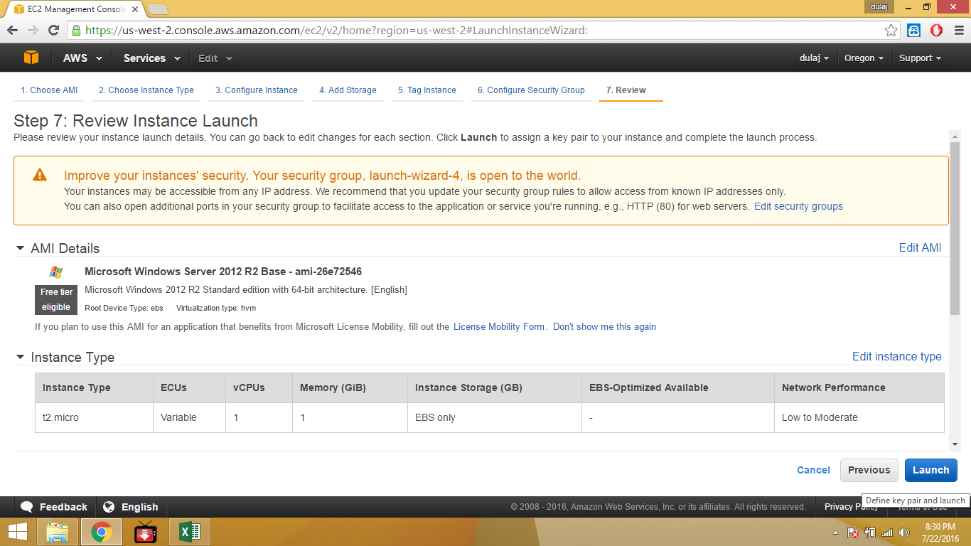 Launch button the server.
5. 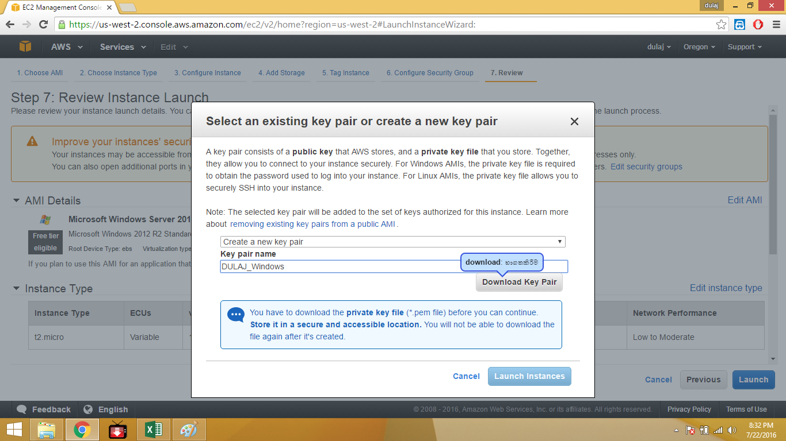Select “create a new pair” and give a name the key pair name.
6. 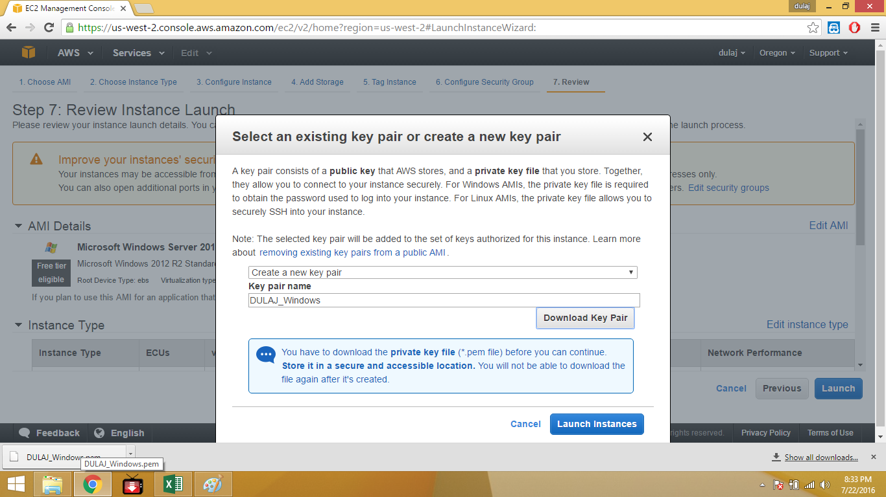Download the “.pem” key file. And launch the instances.
7. 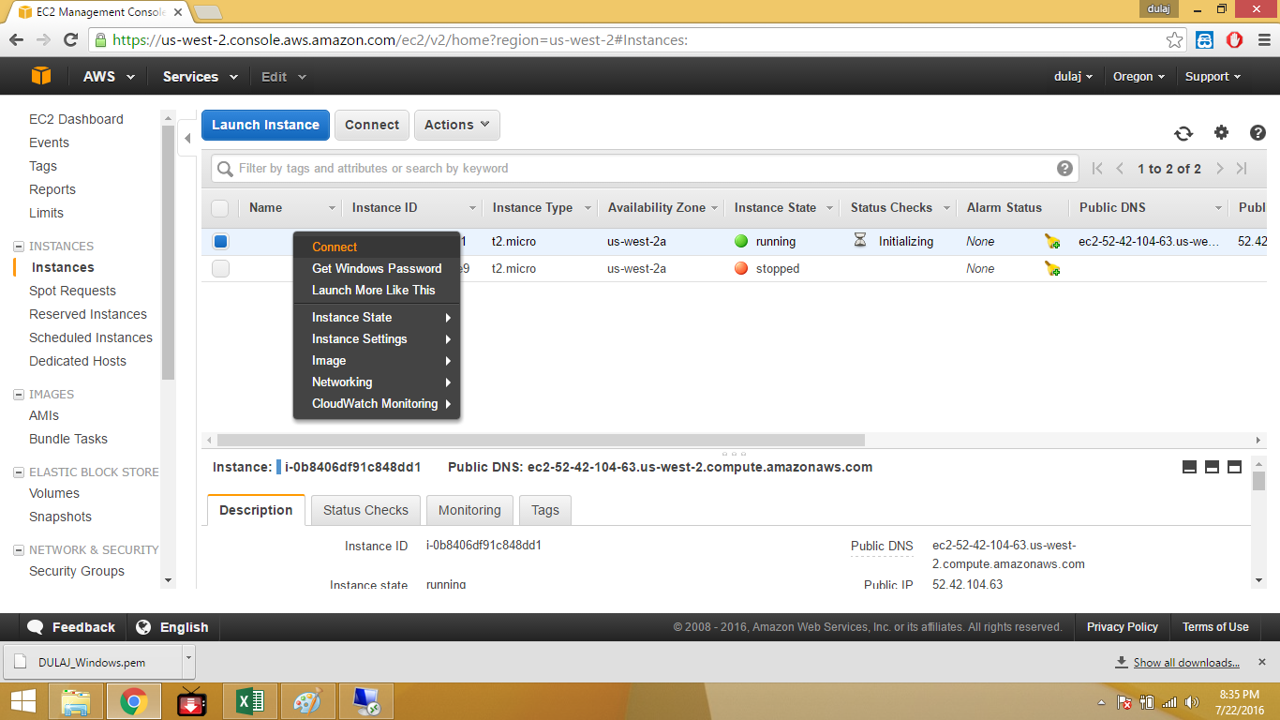Right Click the instance and select connect.
8. 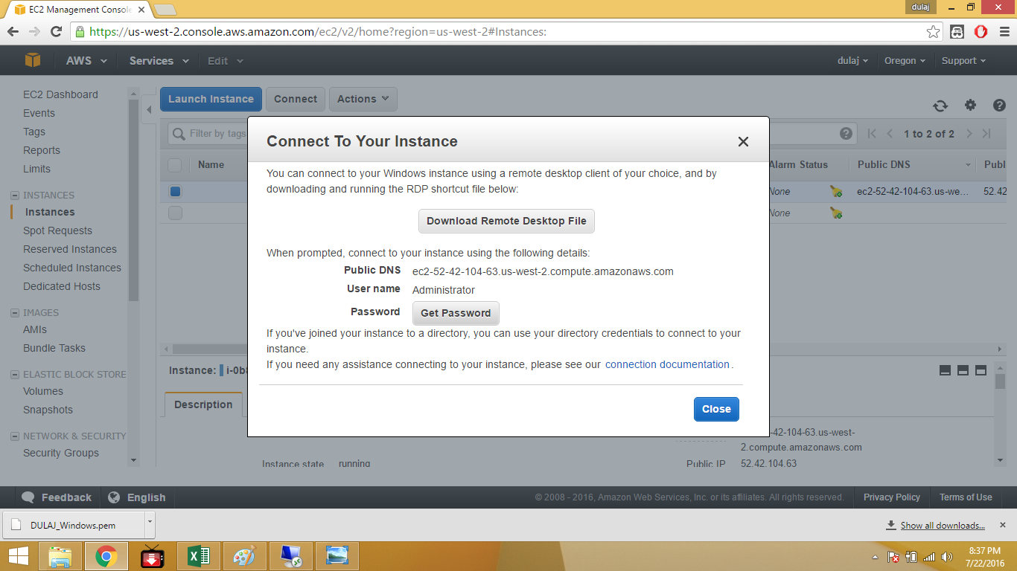Select “Get password”.
9. 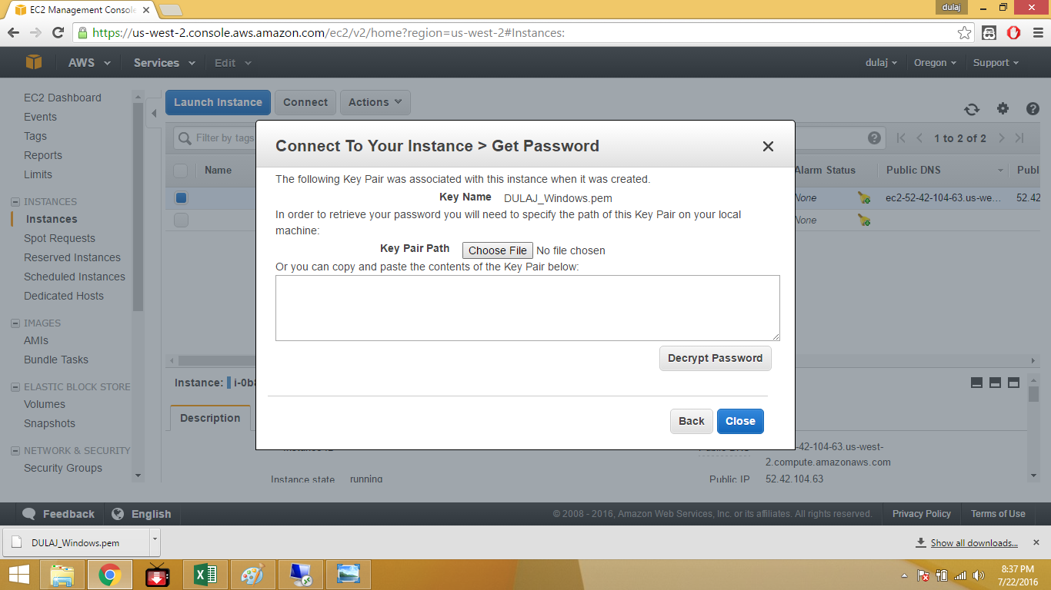Select choose file and select downloaded key.
10. 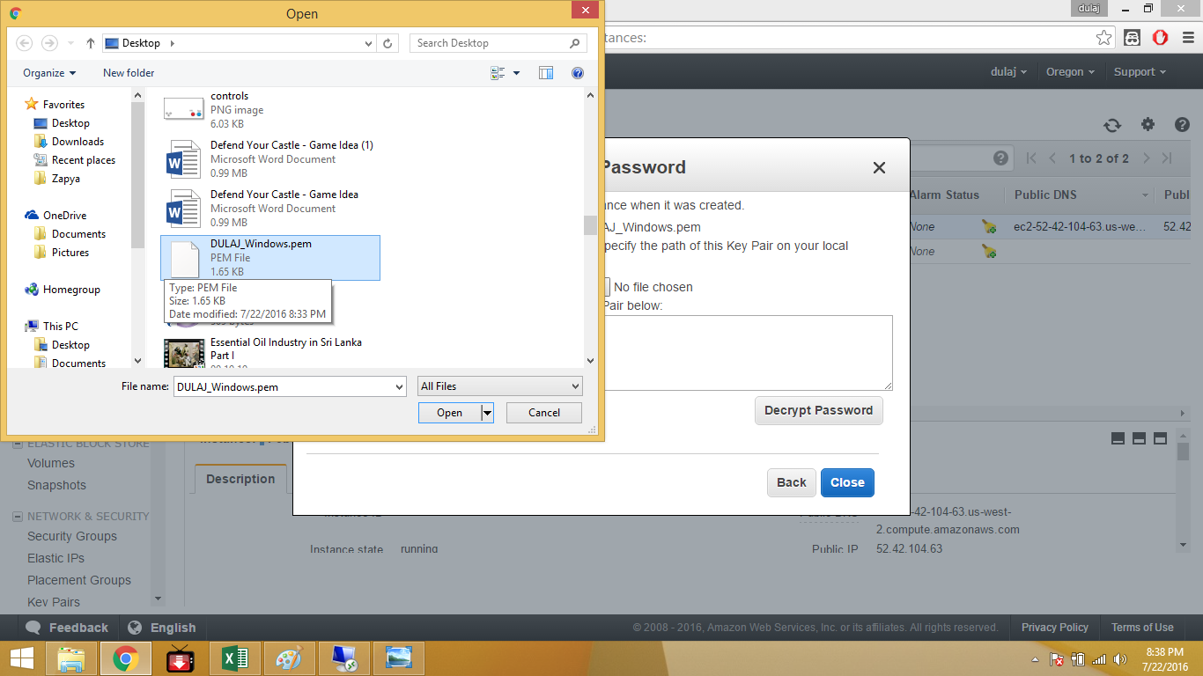Select downloaded key file.
11. 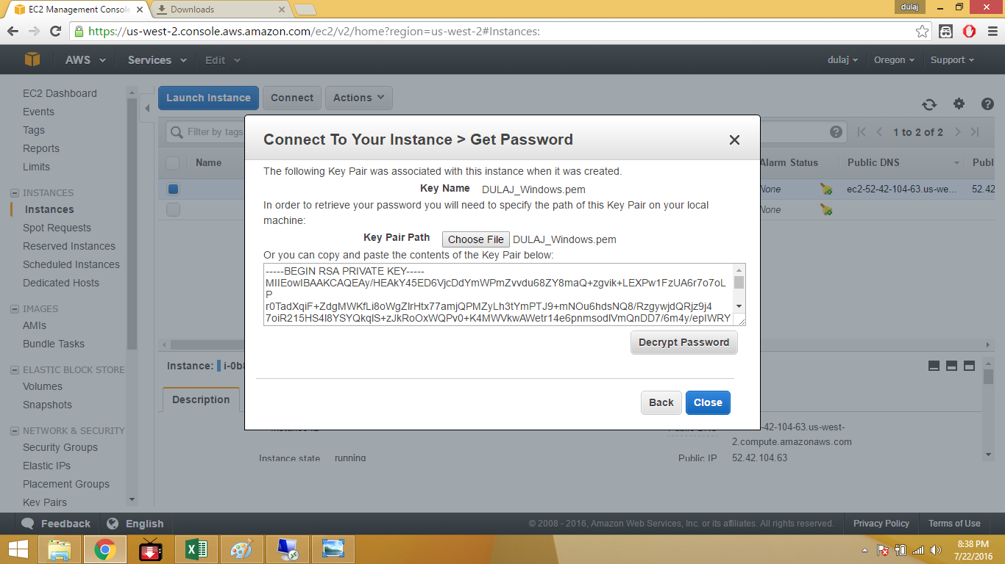Decrypt the password.
12. 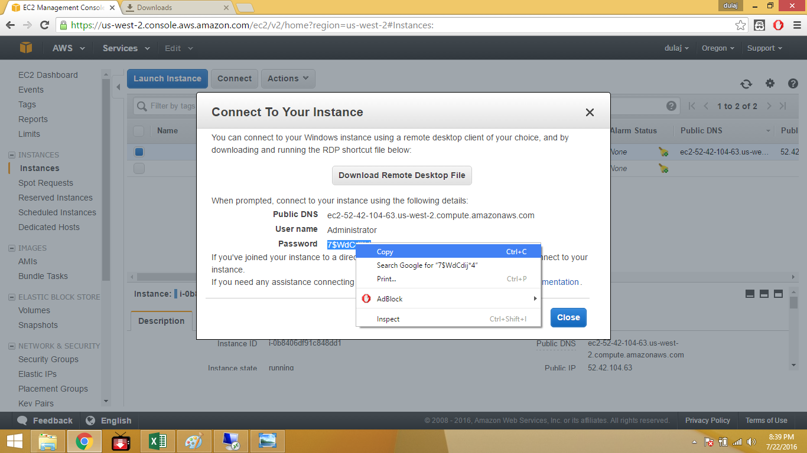Copy the password.
13. 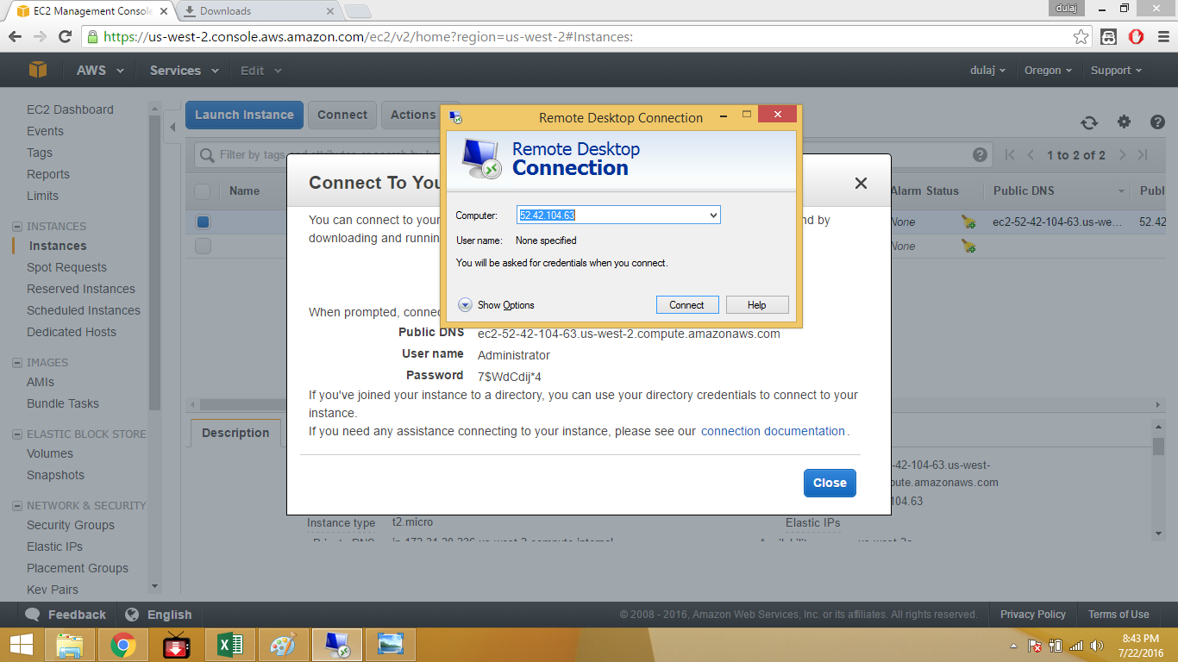Open remote desktop connection. And type the public DNS of the instance.

14.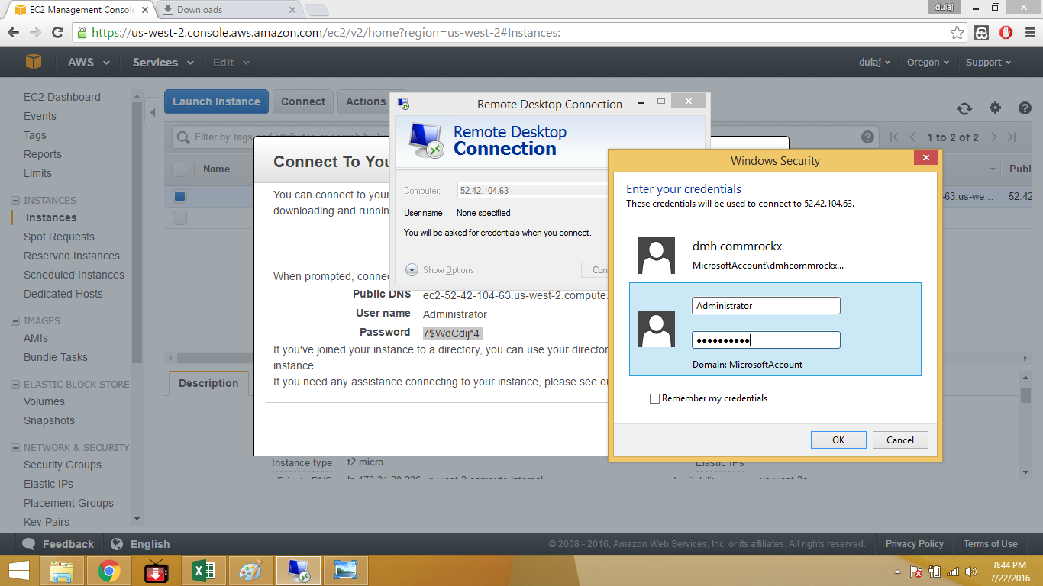 User name is administrator and paste the password.

1. 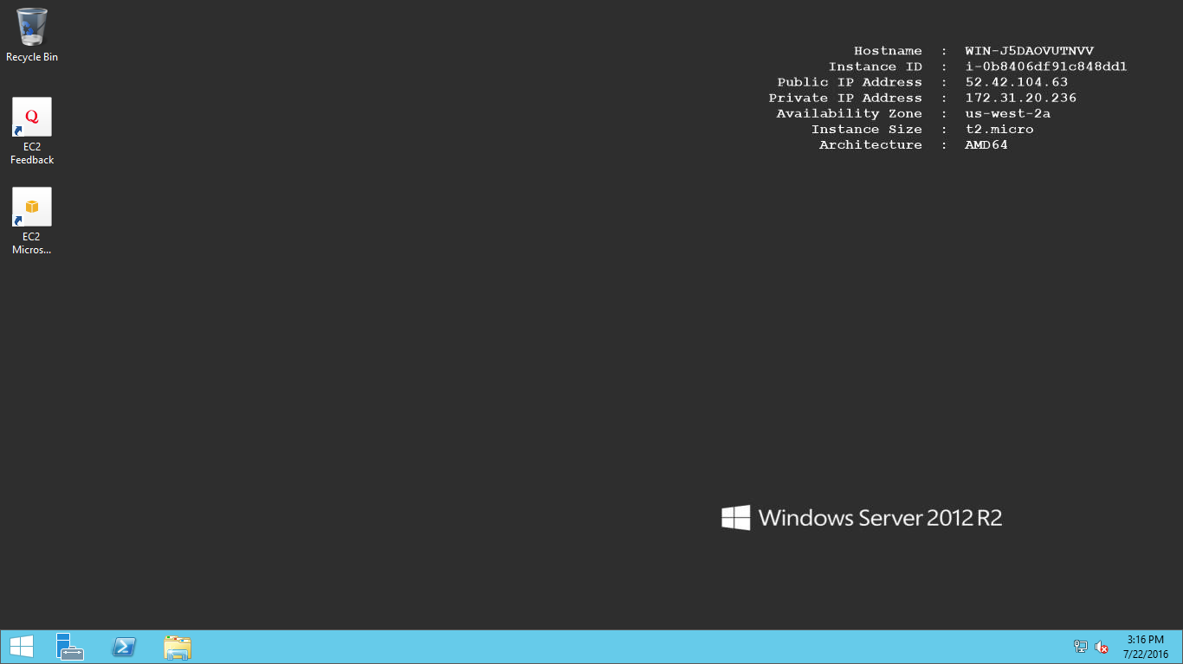After Connect using desktop remote computer user can access in to windows server 2012.

**Linux Instance.**

1. Login AWS and select EC2.



1. Select Ubuntu Server 14.04 LTS (HVM), SSD volume Type

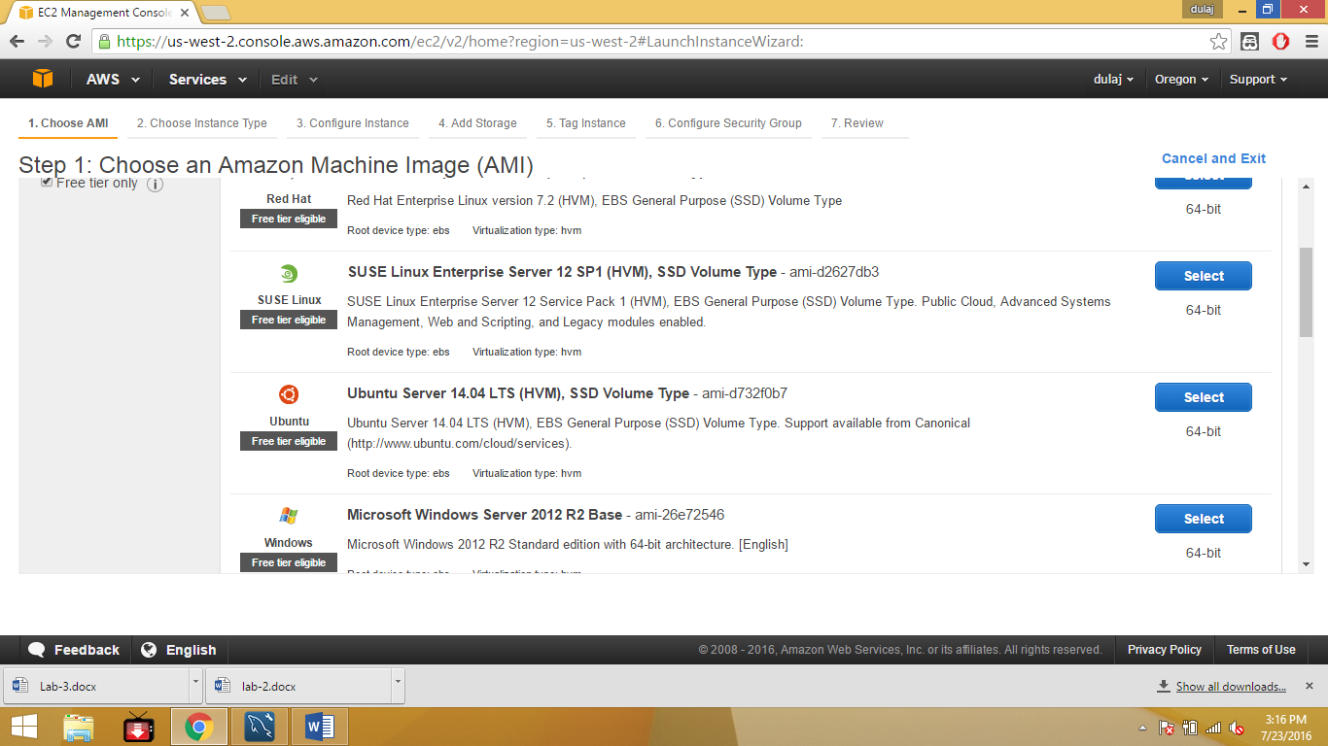

1. 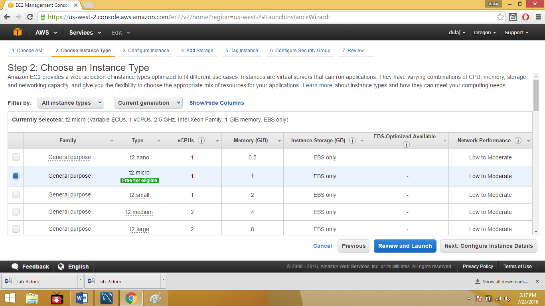Select free available t2.micro.
2. 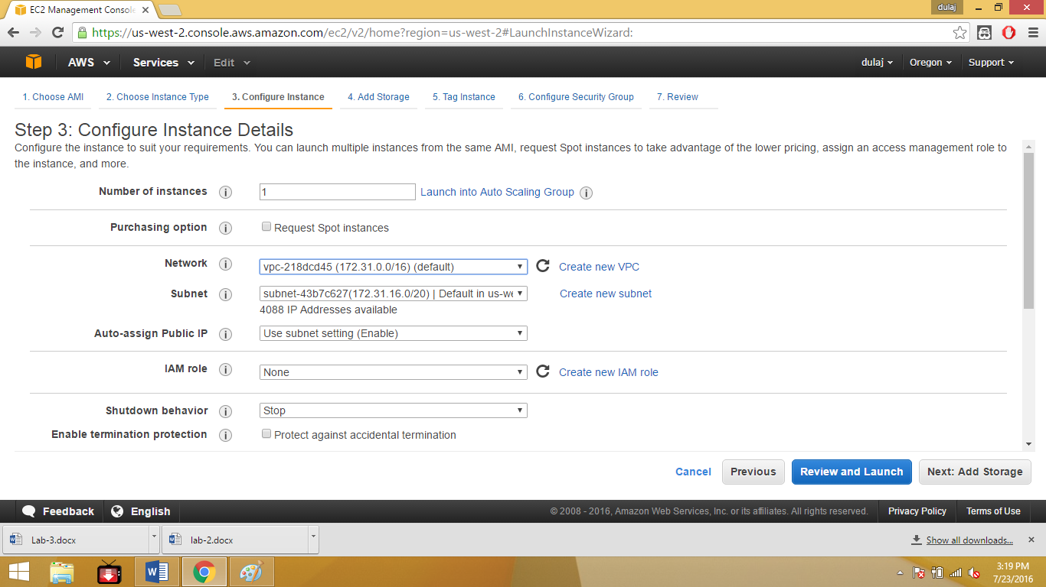Select subnet and Network and select next storage.
3. 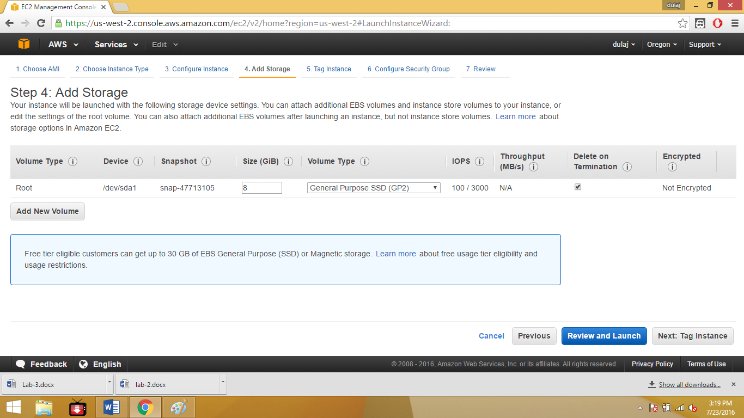Select review and launch. Not modified any details of step 4.
4. 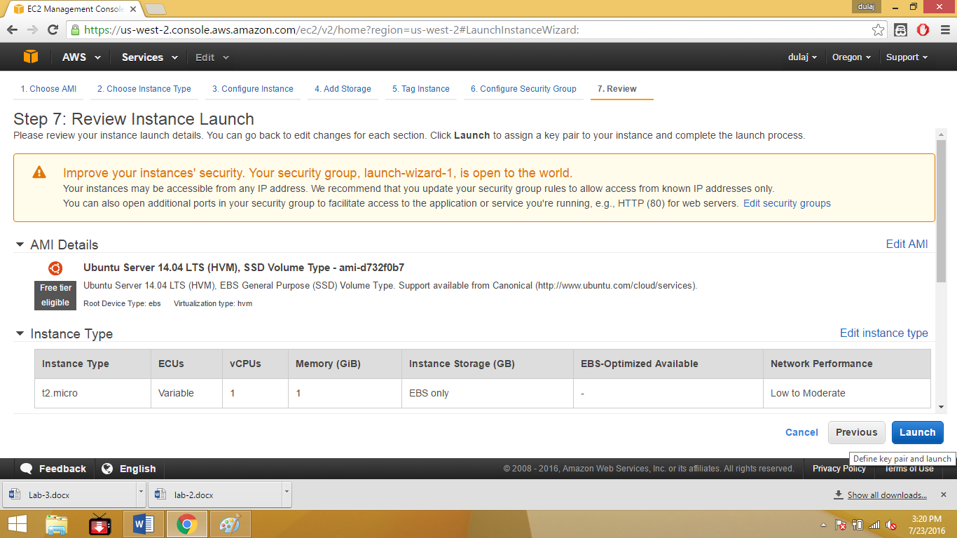Click launch button.
5. Download the key pair.

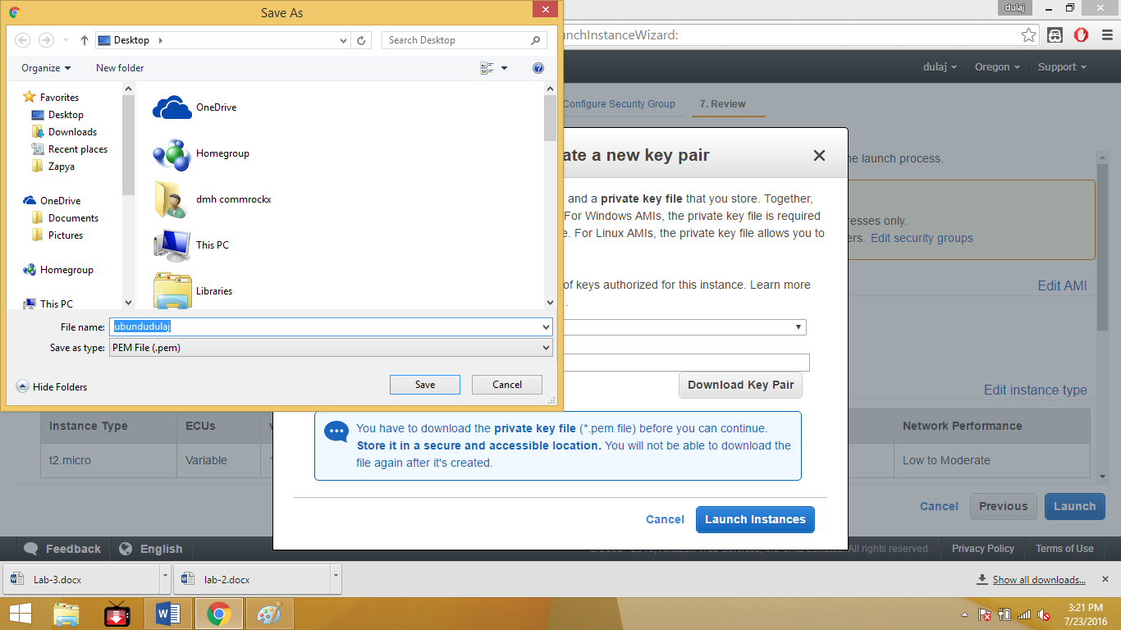

1. Download PuTTYgen.exe to convert PEM to PPK

Run the exe and Load the downloaded key and save the private key.

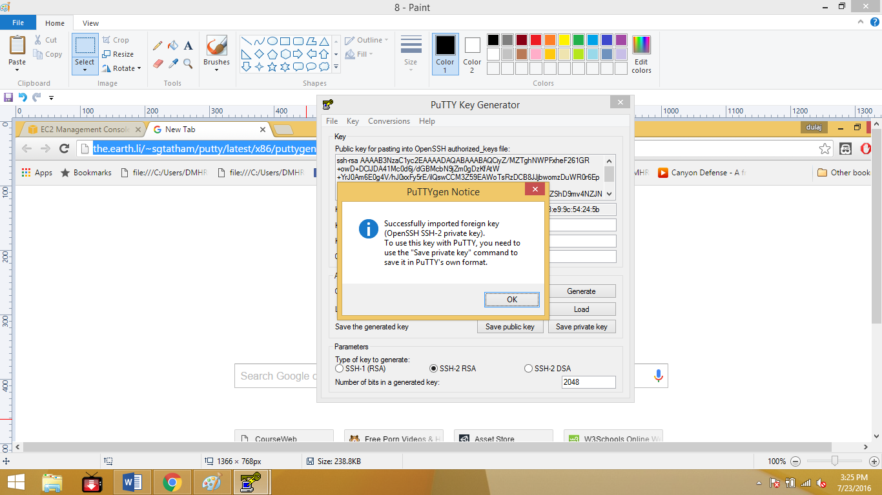Download link is <http://the.earth.li/~sgtatham/putty/latest/x86/puttygen.exe>.

1. Now download the putty.exe. Download link is

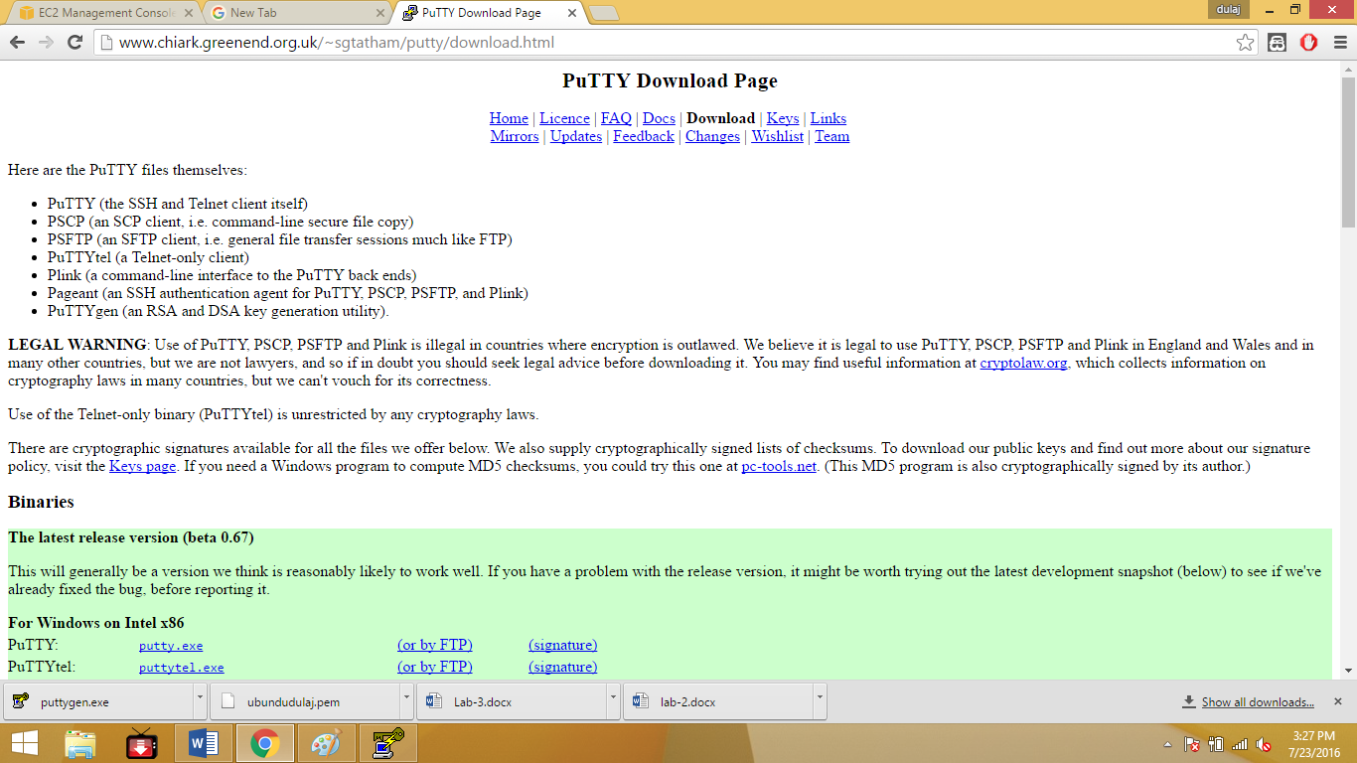<http://www.chiark.greenend.org.uk/~sgtatham/putty/download.html>.

1. Copy the public DNS of the created instance and paste on host name type “ubuntu@”

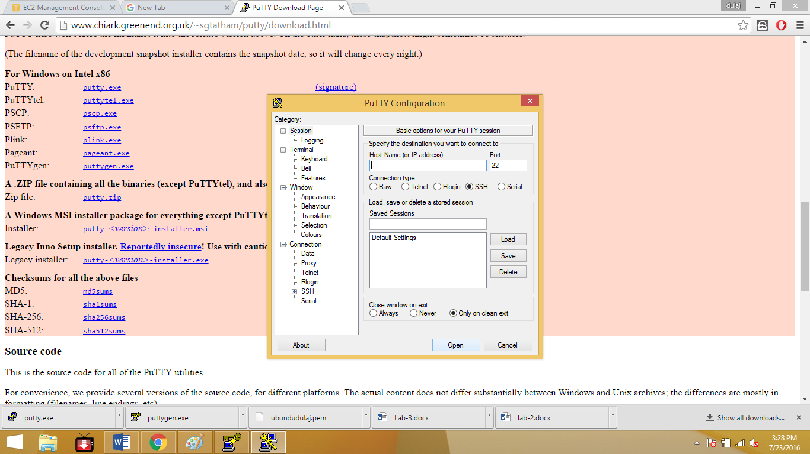Before the address.

1. 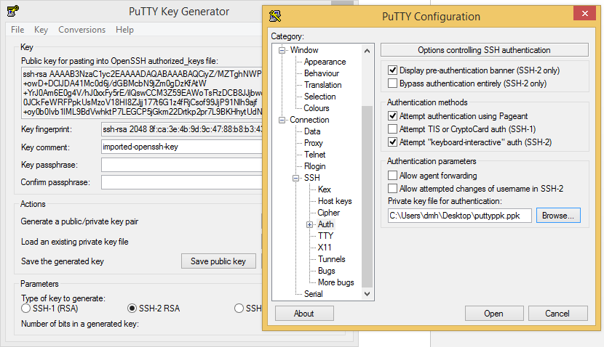Then under Connection-> SSH-> Auth browse the saved key. Then select open
2. 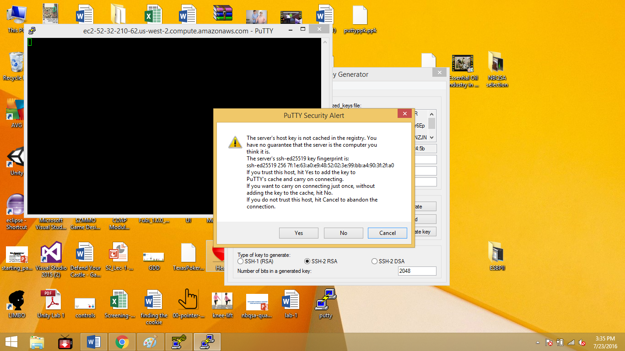Select “yes”.
3. Then launch the Ubuntu server.

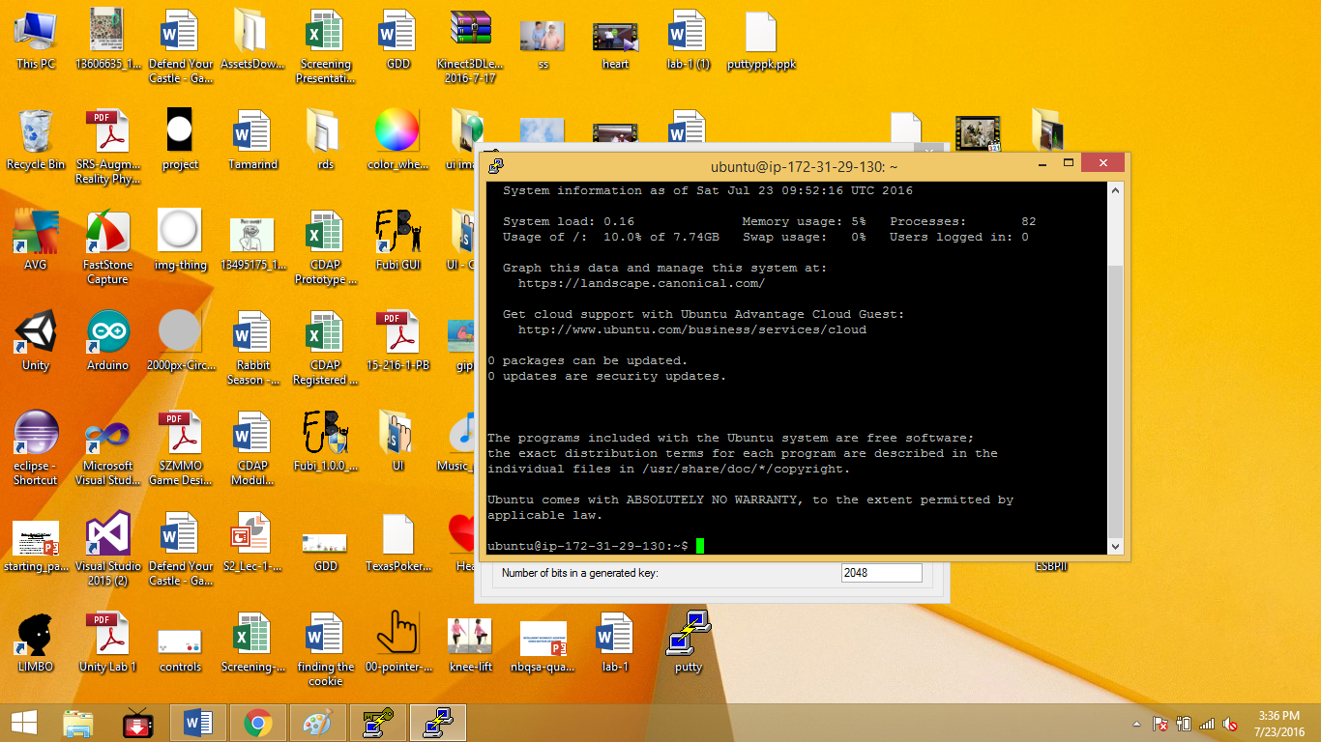

1. 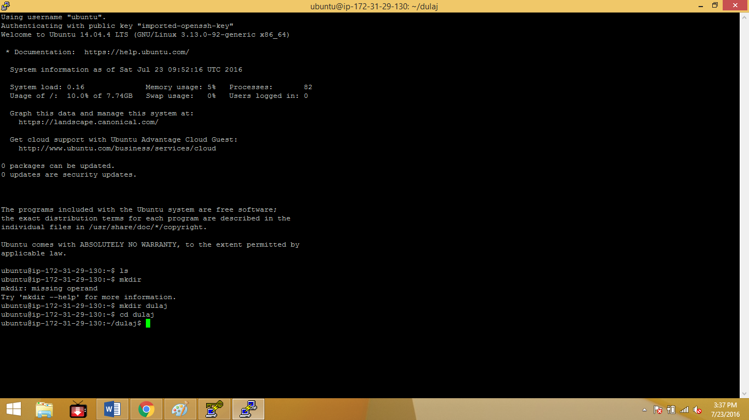Use mkdir command to create a directory.

**DB instance (MySQL).**

1. 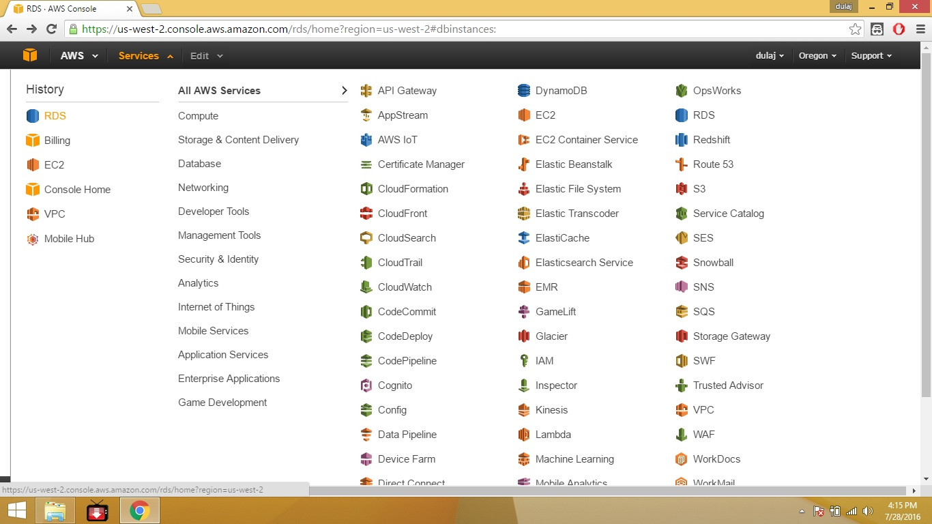Go to RDS and select RDS.
2. Go to subnet group and select create Subnet group.

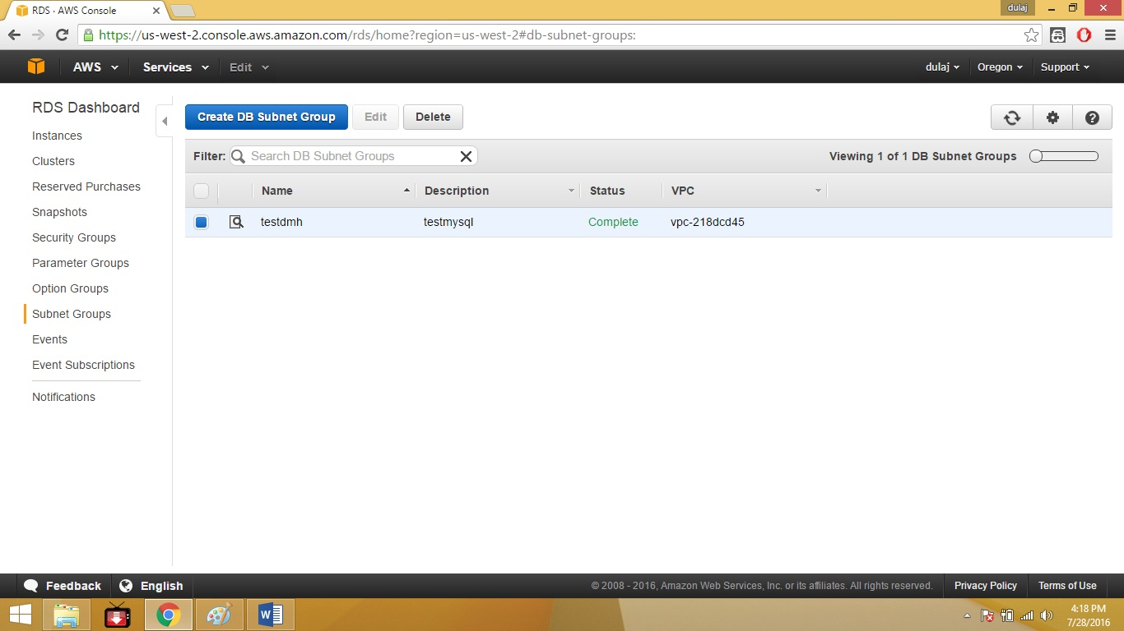

1. 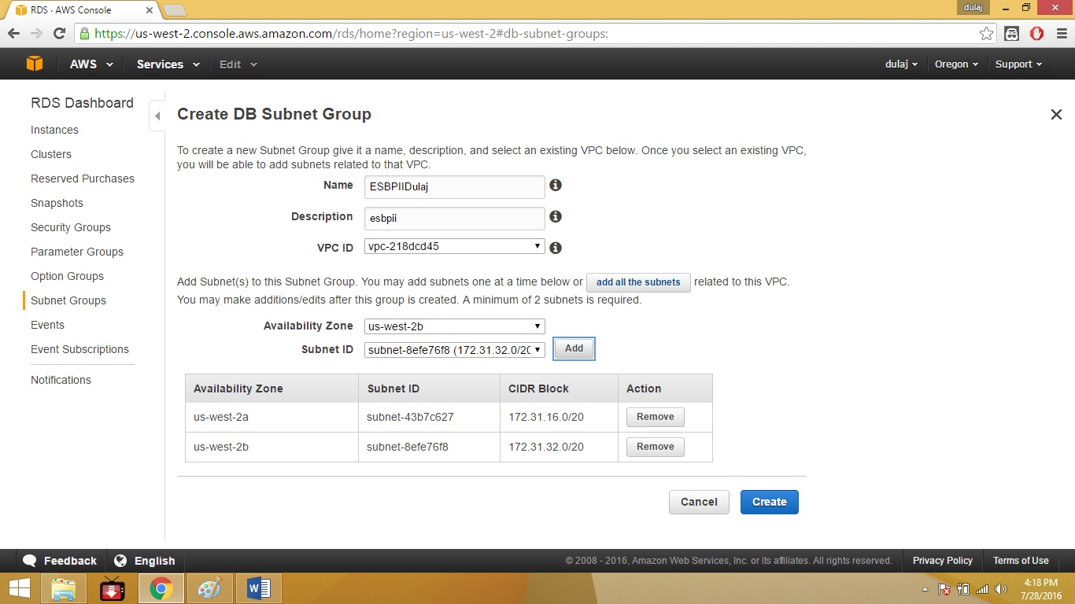Type a name description and select VPC. Add minimum two subnets and select create.
2. 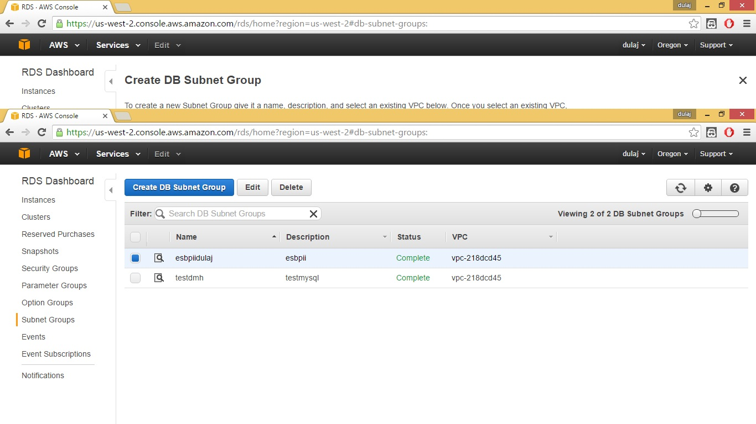There is created subnet group.
3. 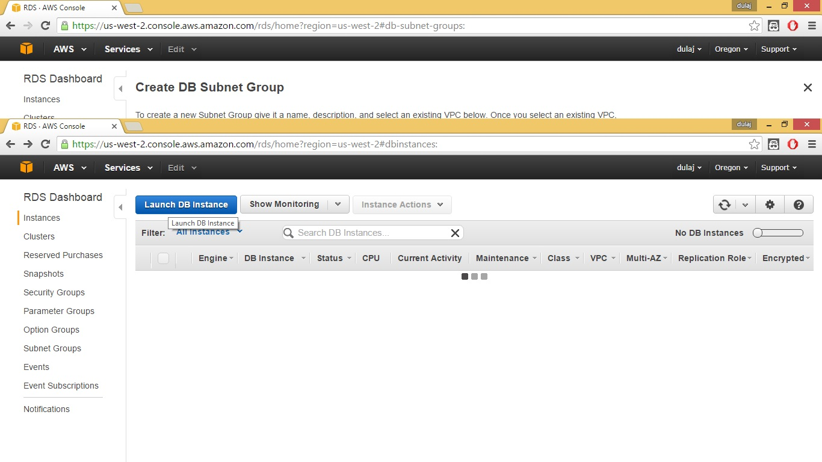Go to instances and select “Launch DB Instance”.
4. 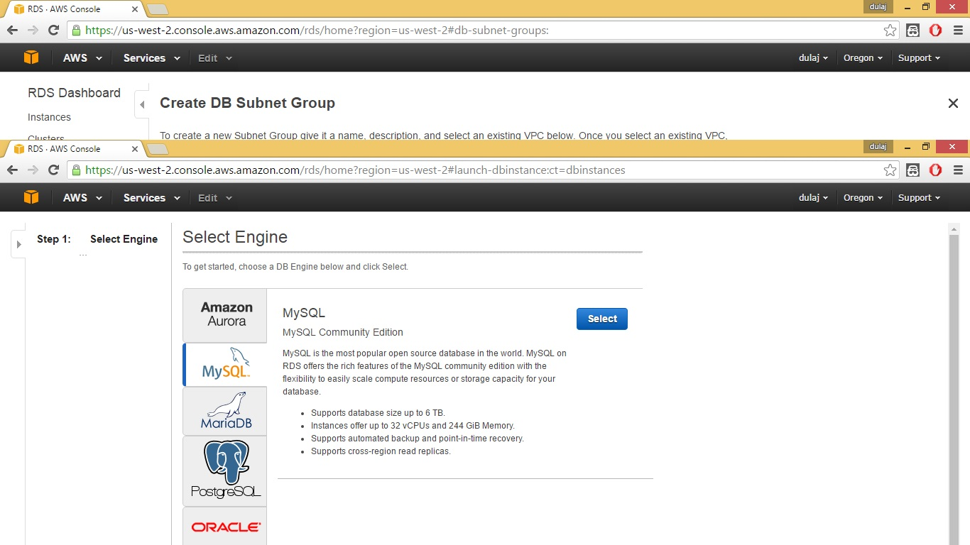Select MySQL as the engine.
5. 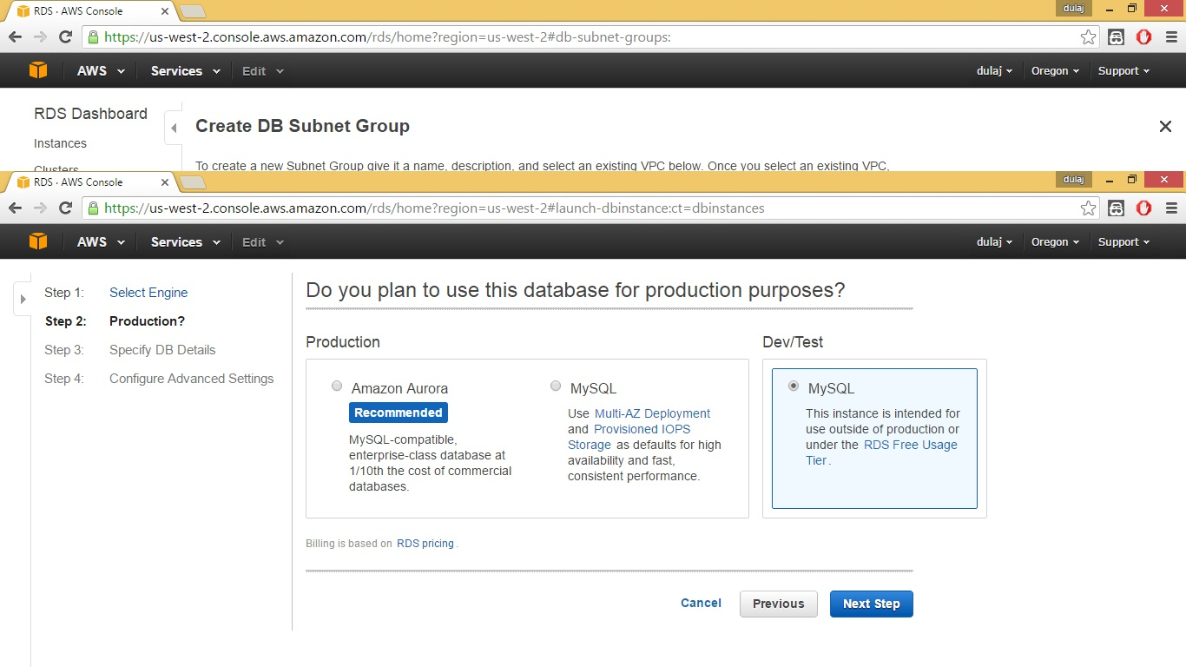Select Dev/Test it is free and select next.
6. 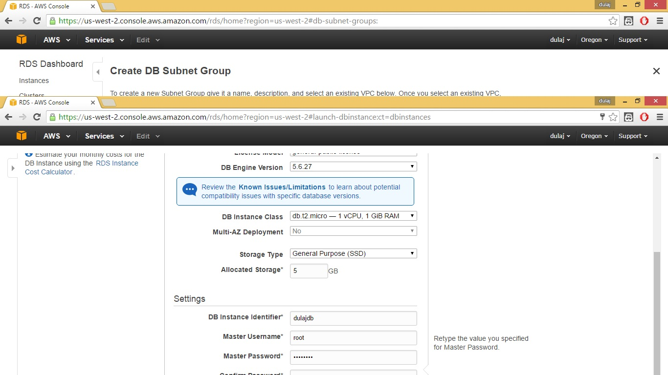Select DB instance class as follows.

1. 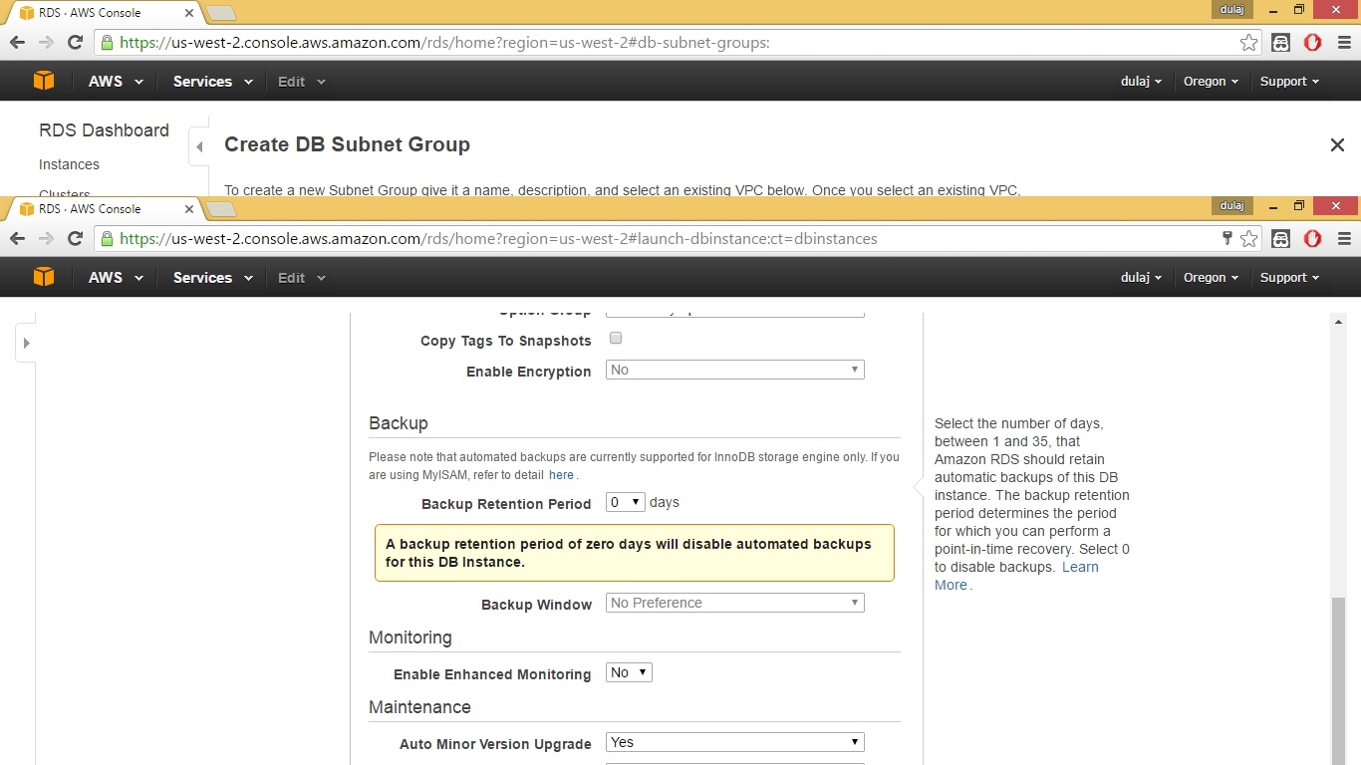Set backup period to Zero days. And launch the DB instance.
2. 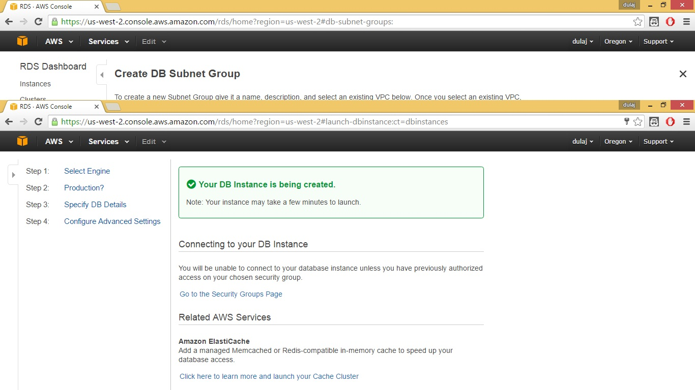Then our DB instance is created.
3. 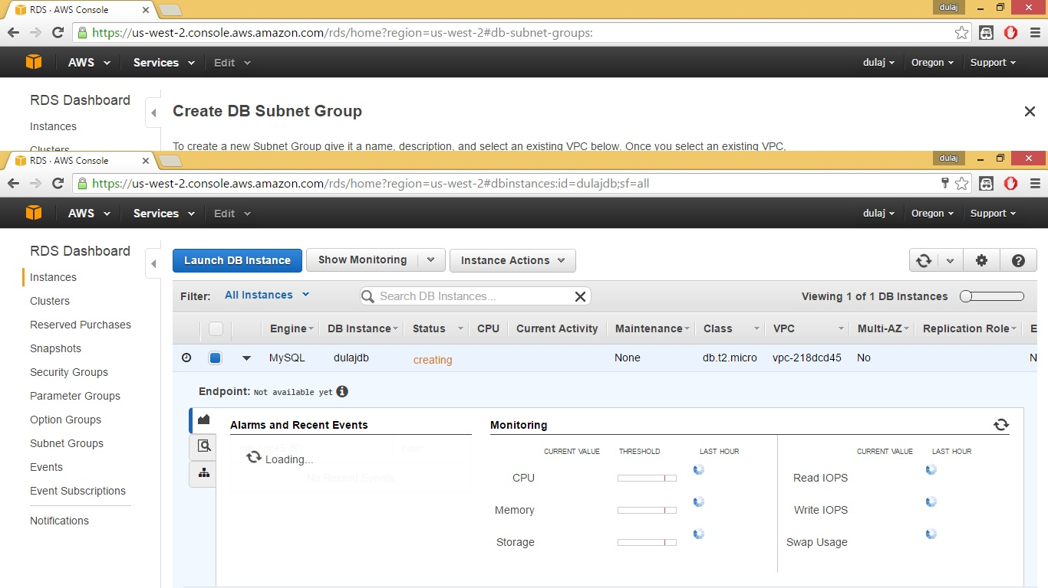When we navigate to instances. It take few minutes to create the instance.
4. 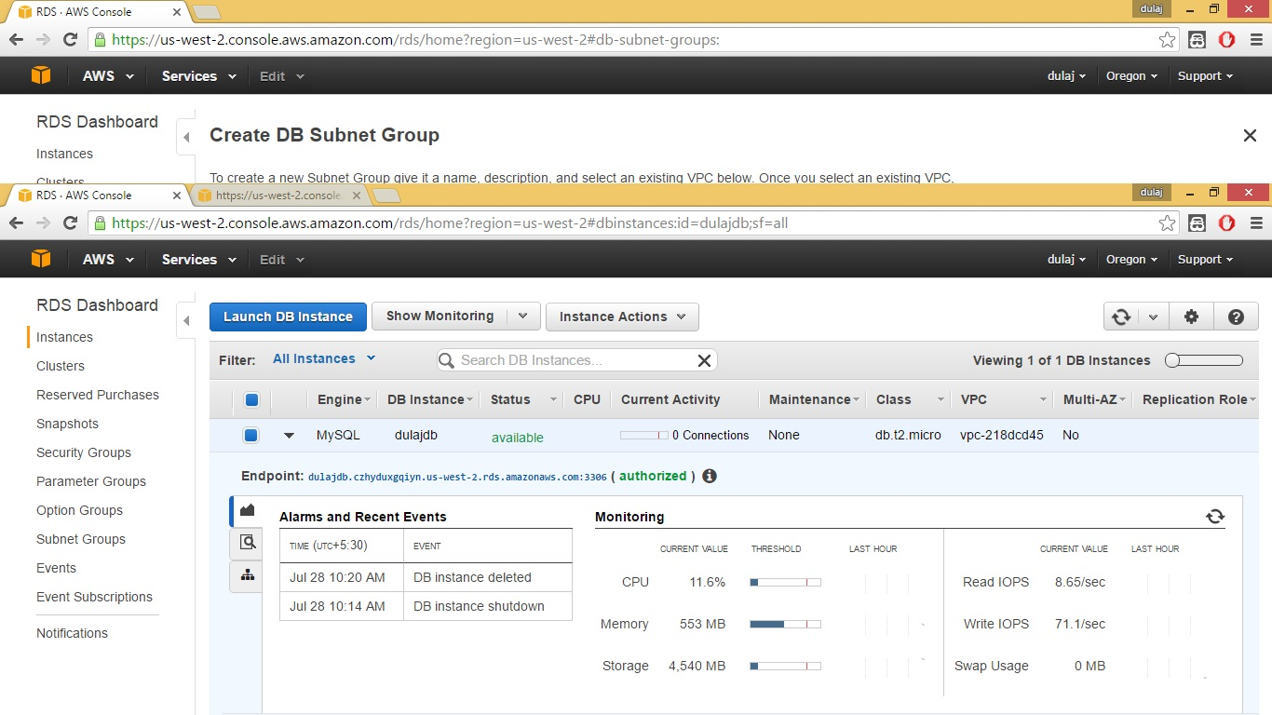After few minutes it’s available for use.
5. 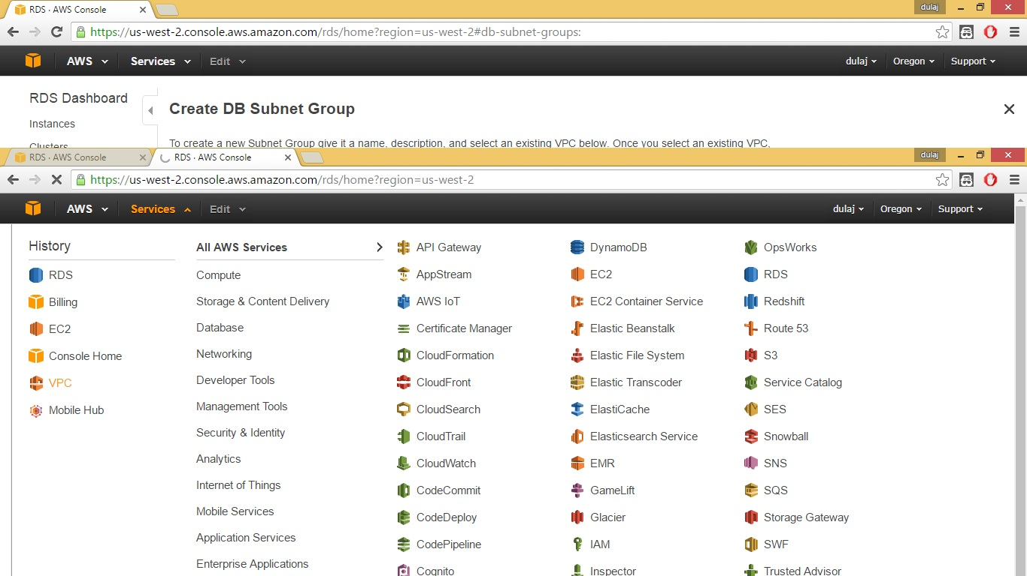Then navigate to VPC.
6. 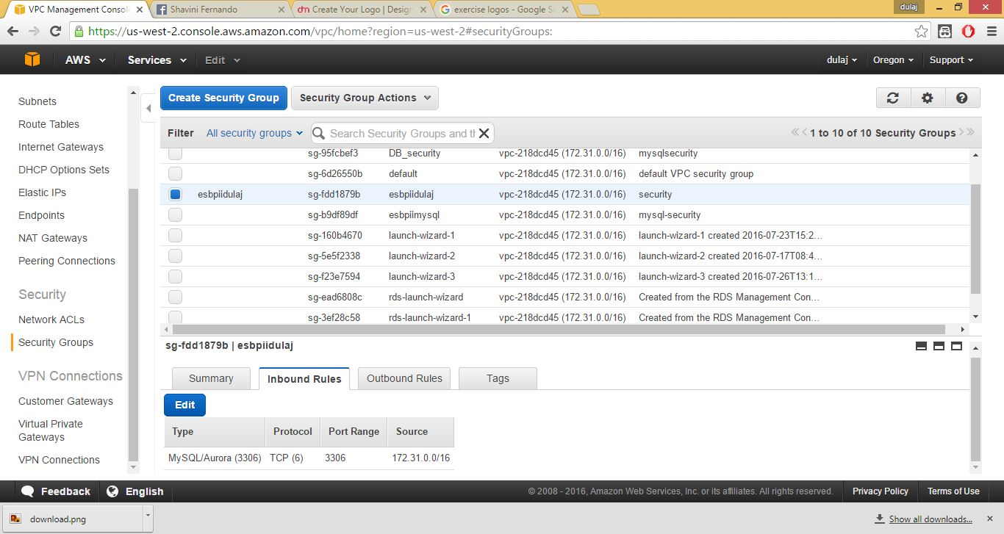Create a security a group and Edit inbound rules as follows.
7. Go to security groups under EC2 management and create a security group. Edit rules as follows.

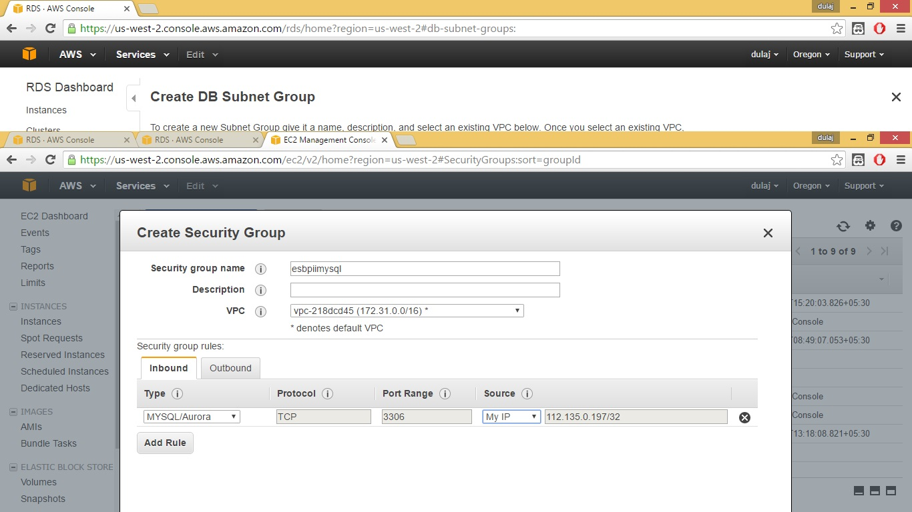

1. Go to instance we create and right click and select modify.

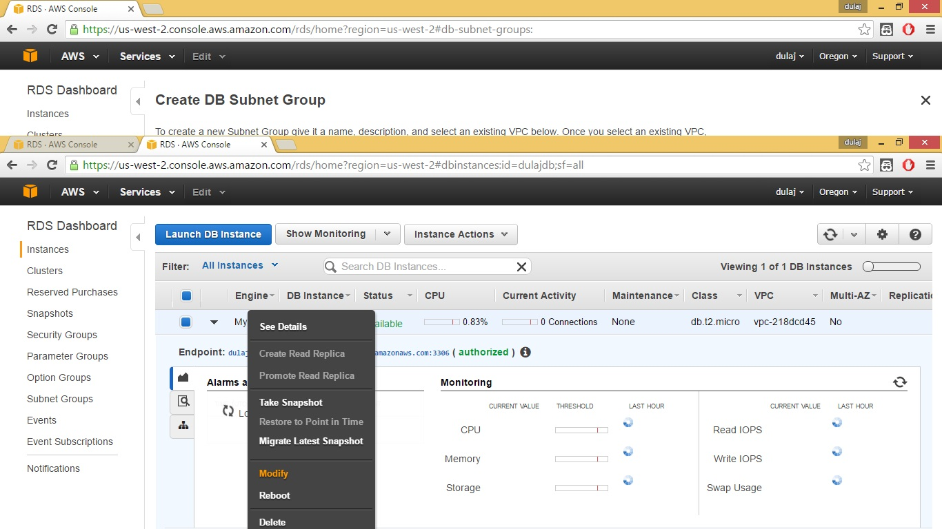

1. 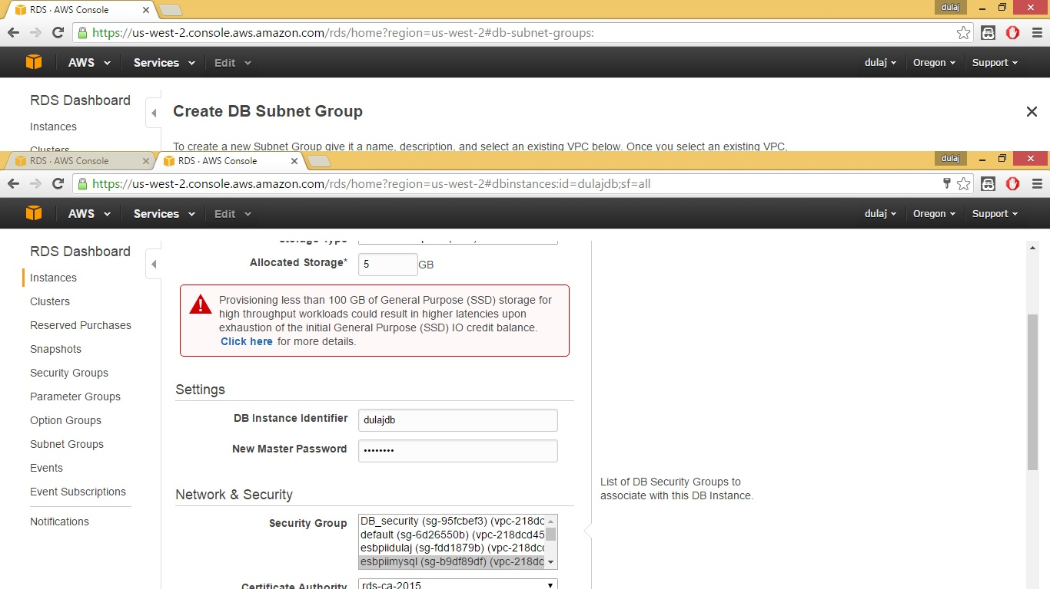Select security group that we created. Apply immediately and continue.
2. 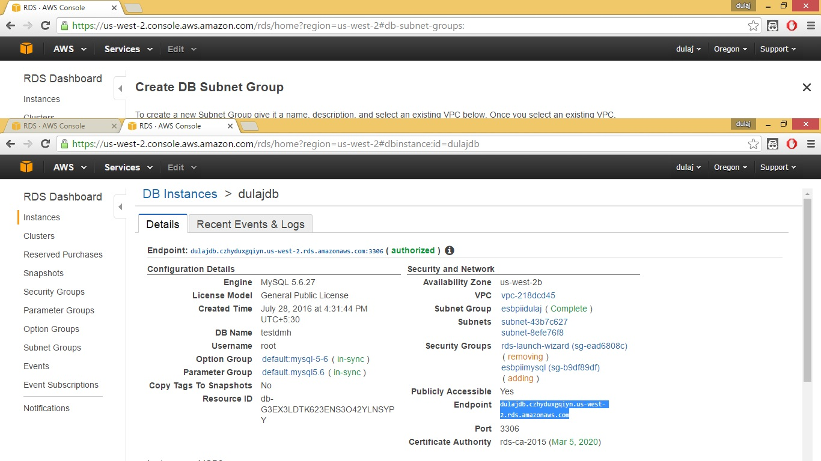Select instance and get details. Under details there is end point. Copy it.
3. 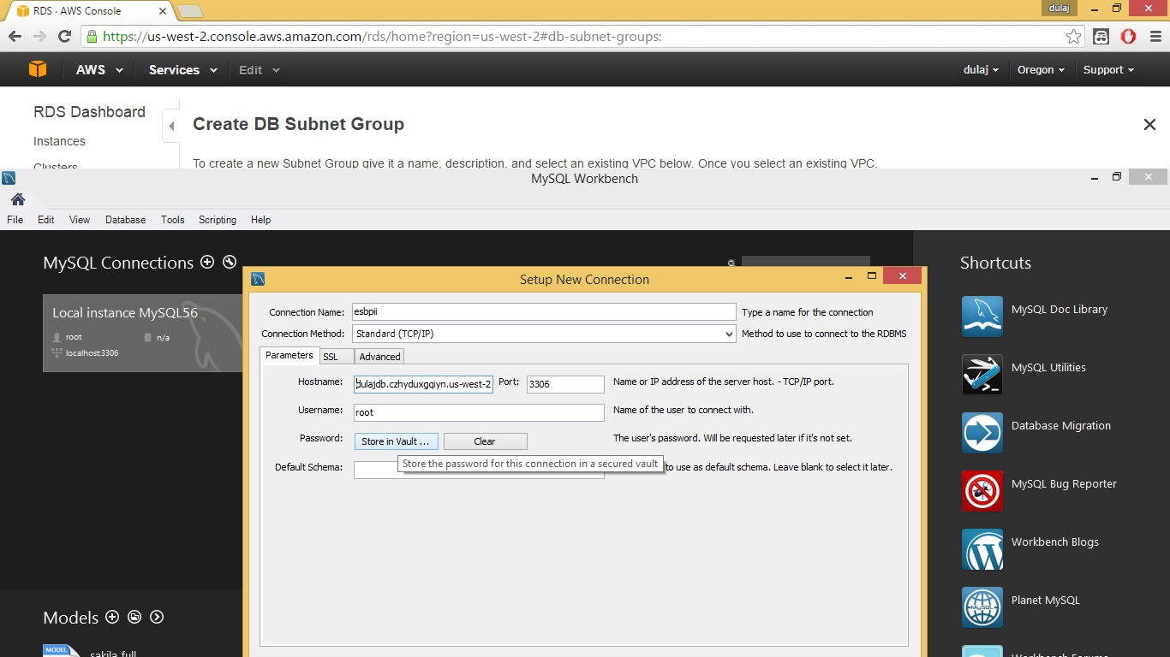Open MySQL workbench and Give a connection name and give the end point as the hostname.